**Employee ID: ACFS2395**

**Name: Pavankumar Y G**

**Role: Jr.Software Engineer**

**ABOUT JIRA:**

• JIRA is an incident management tool.

• JIRA is developed by Atlassian Inc. an Australian Company.

• JIRA is a platform independent tool; it can be used with any OS.

• JIRA is multi-lingual tool − English, French, German, Japanese, Spanish, etc.

• JIRA supports MySQL, Oracle and SQL server in the backend.

**USE OF JIRA:**

• JIRA is used in Bugs, Issues and Change Request Tracking.

• JIRA can be used in Help desk, Support and Customer Services to create tickets and track the resolution and status of the created tickets.

• JIRA is useful in Project Management, Task Tracking and Requirement Management.

• JIRA is very useful in Workflow and Process management.

To create a project, the user should login as a JIRA Service Desk Admin and then Click on Project → Create Project OR Login with email then give some name it will automatically create project name The following screenshot shows how to reach to the Create Project

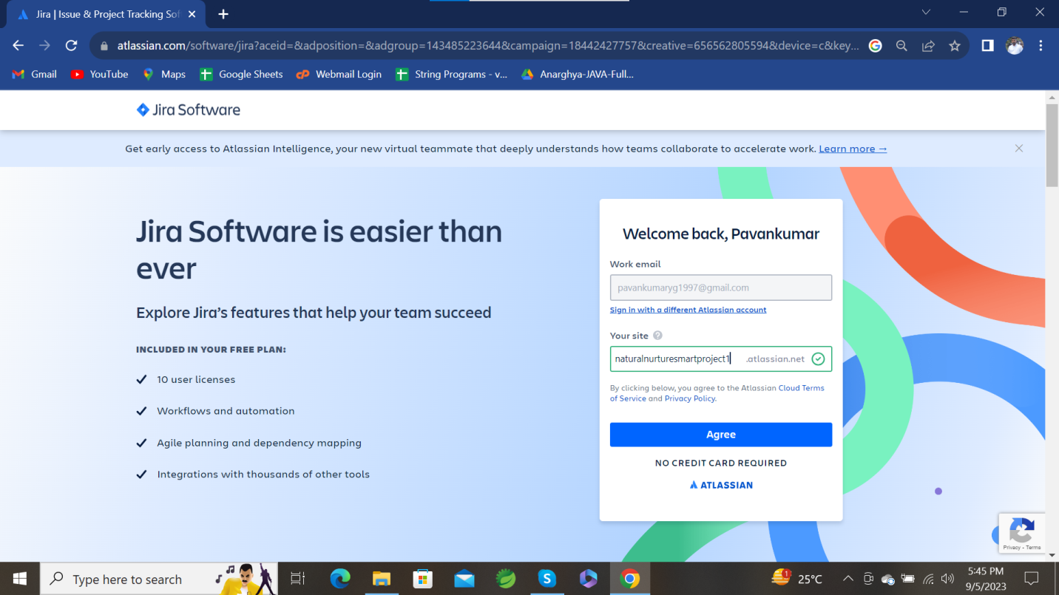

Select a Template for your first project, in that select scrum

Below screenshot shows the template selection:

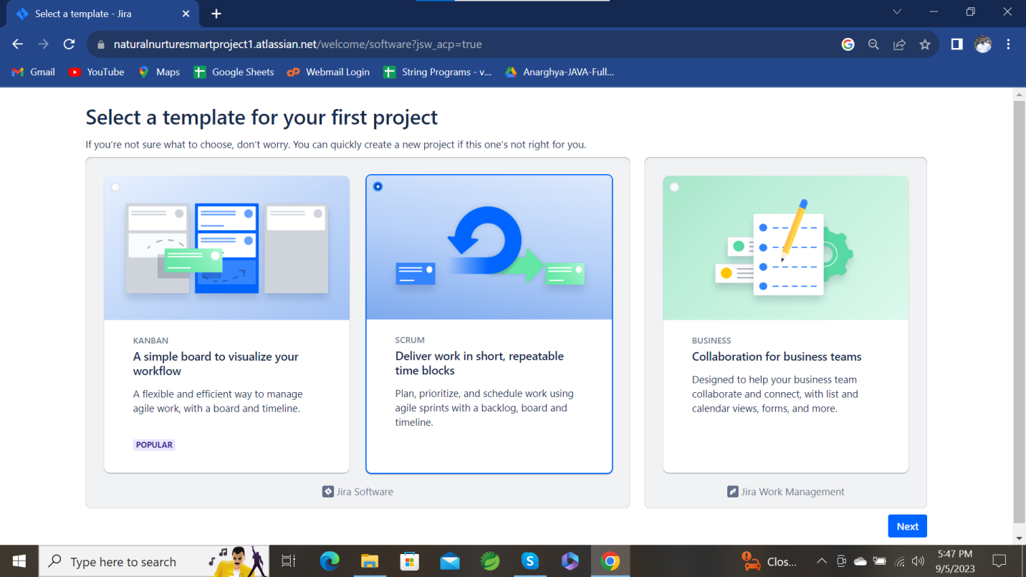

After the creation of project, you need to add scrum names which the work you have to assign your team members.

In that you can add issues, sub modules and assign the tasks to your team members by through their mail id

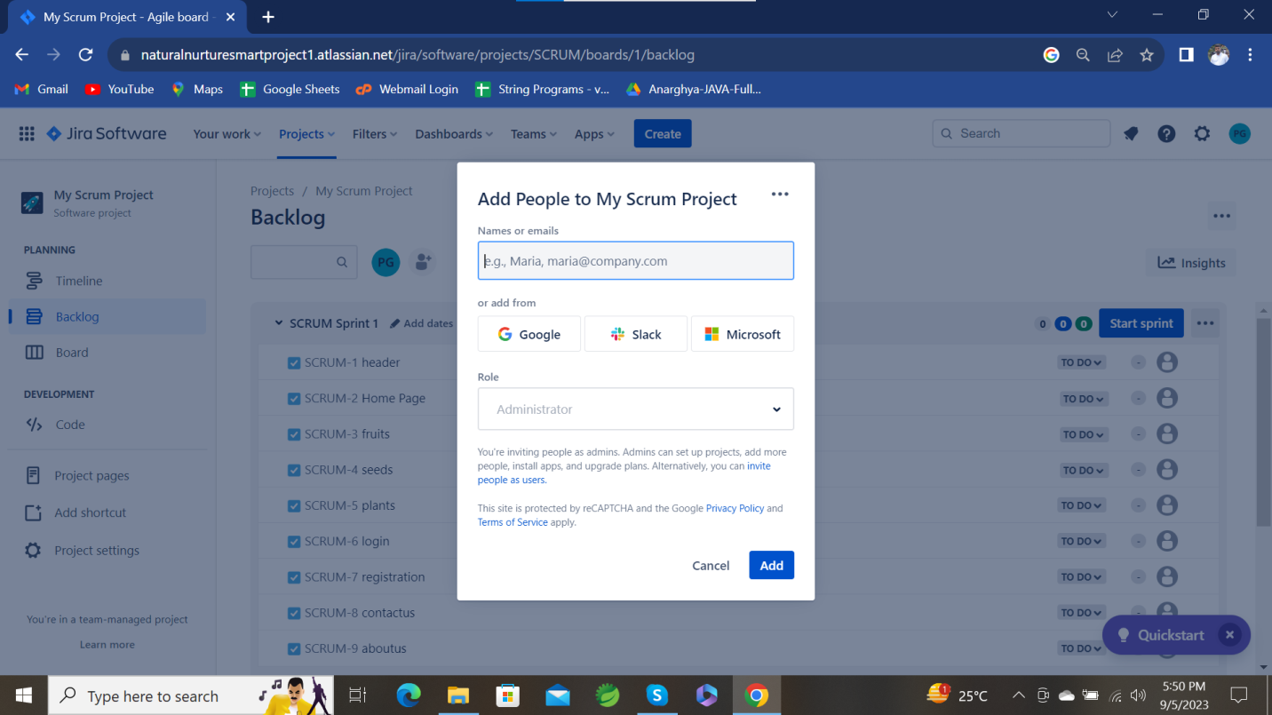

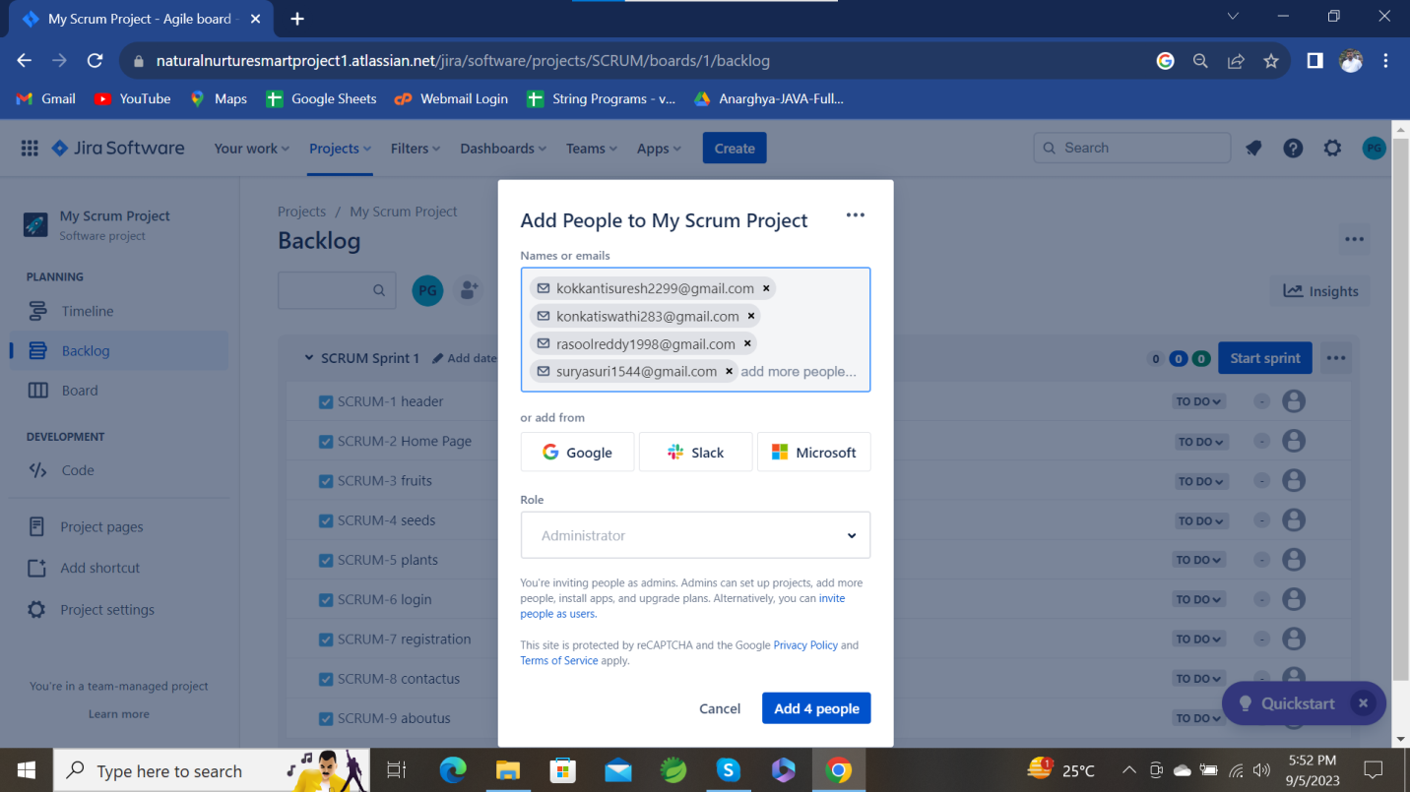

**CREATE WORKFLOW:**

To create workflow, go to scrum module name, right side there is To Do option, click on that then click on workflow to create status

I have added testing and QA-Testing-Rejected and then adjust your workflow sheet

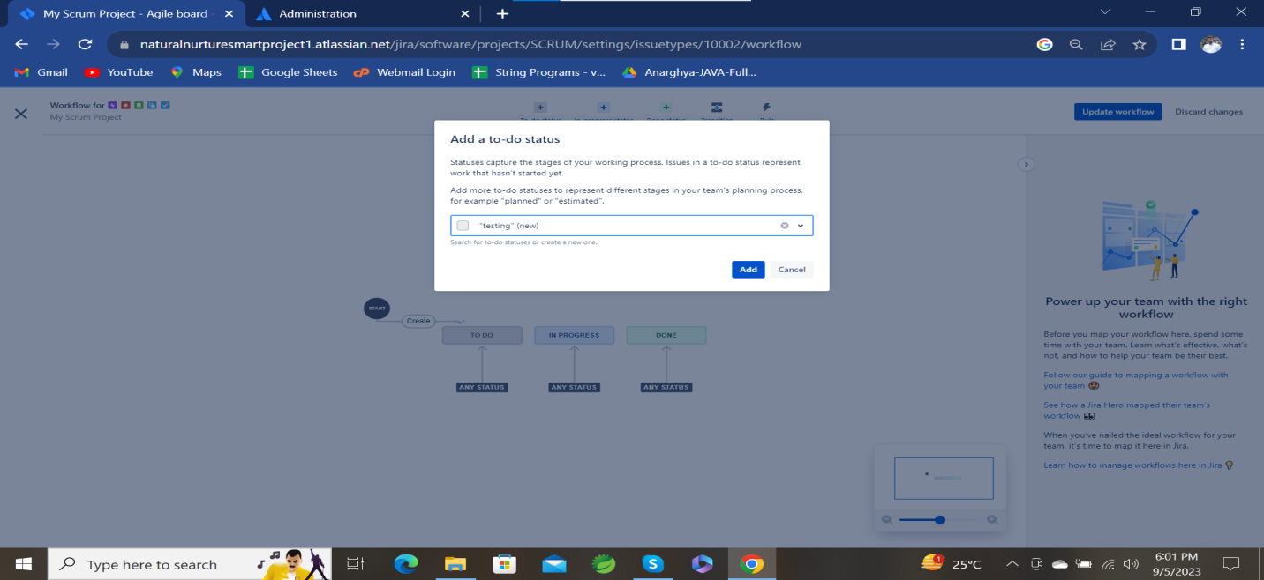

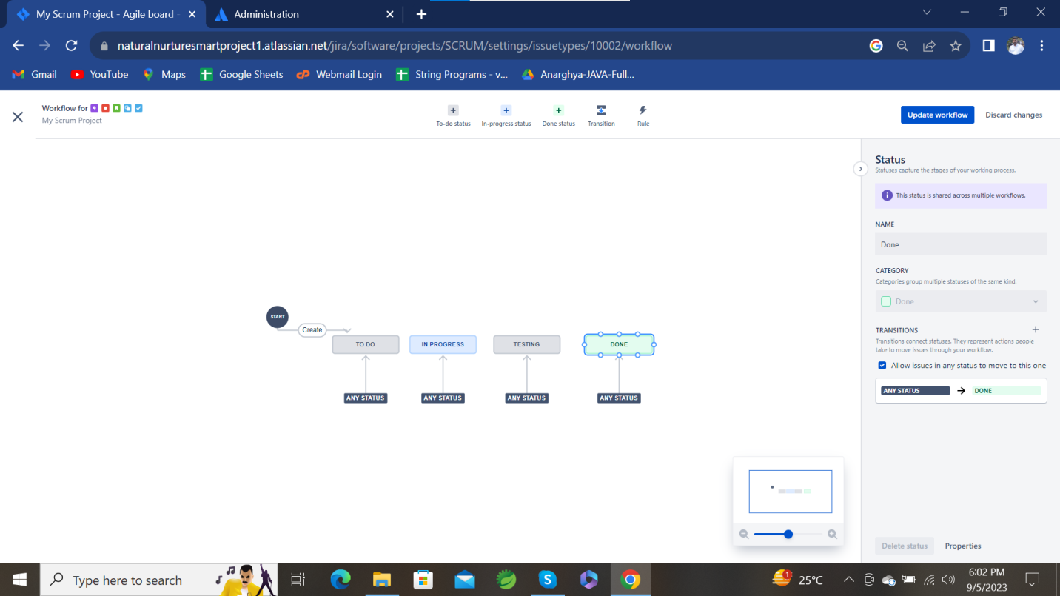

**Adjust workflow:**

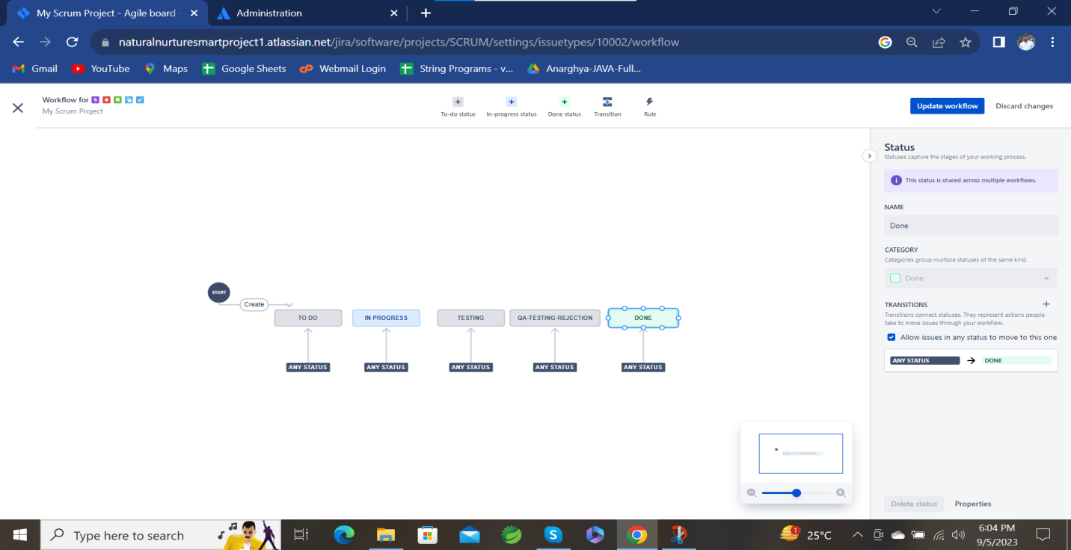

In the below screenshot I have created project and assigned work to my team member’s.

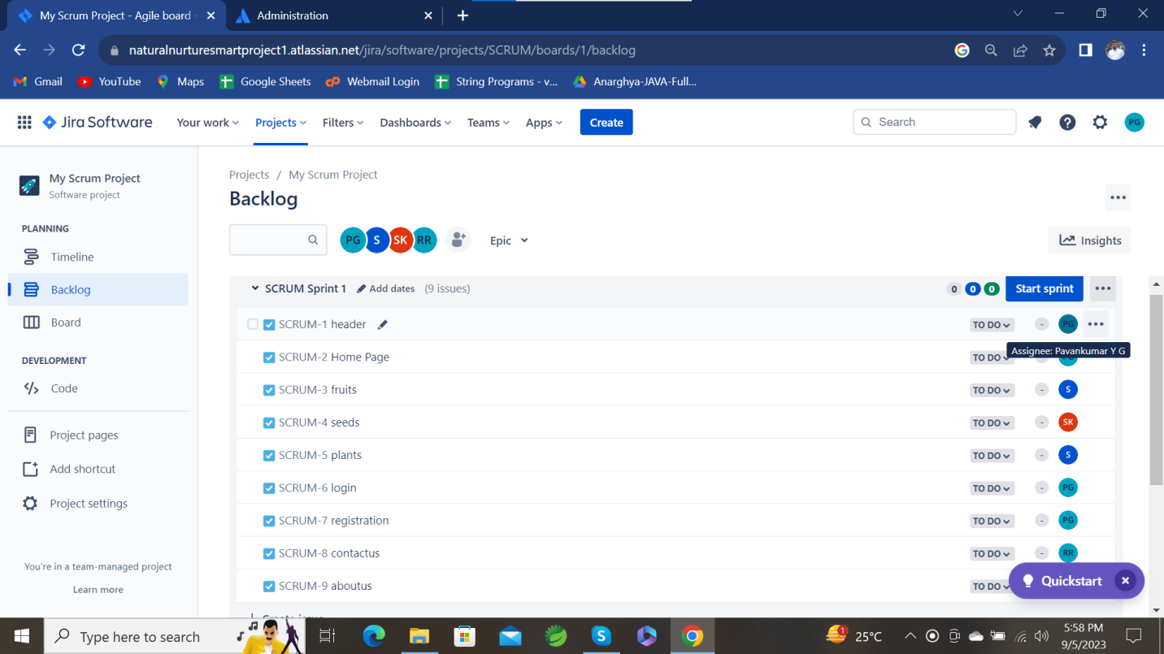

**After starting the sprint all the issues moves to board, then the workflow will start’s**

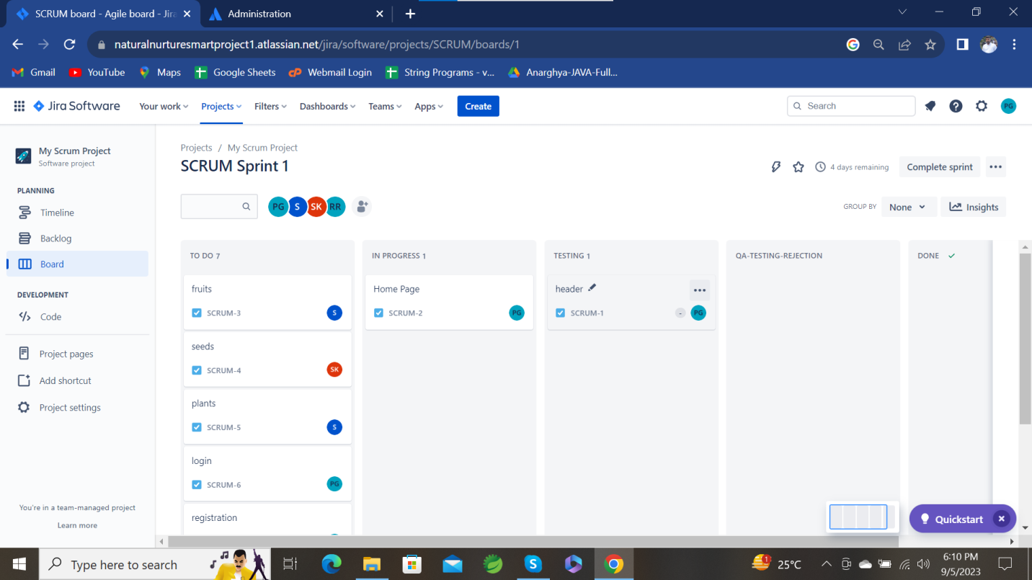

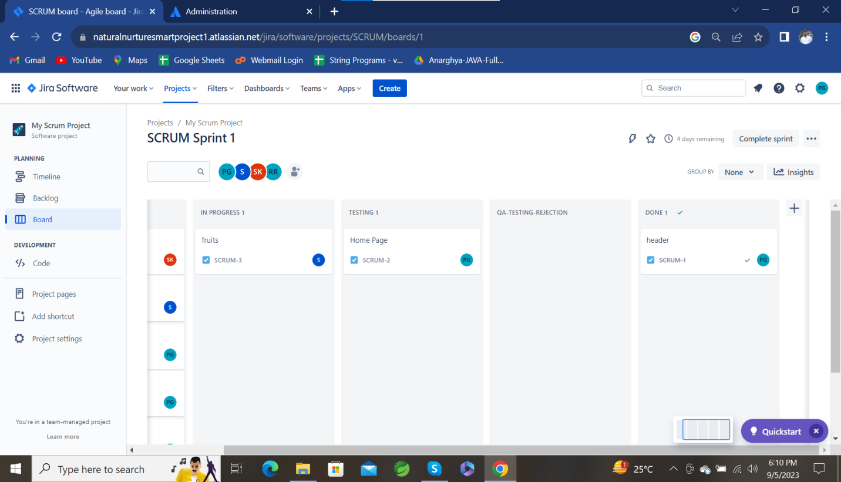

**Last stage of the workflow**

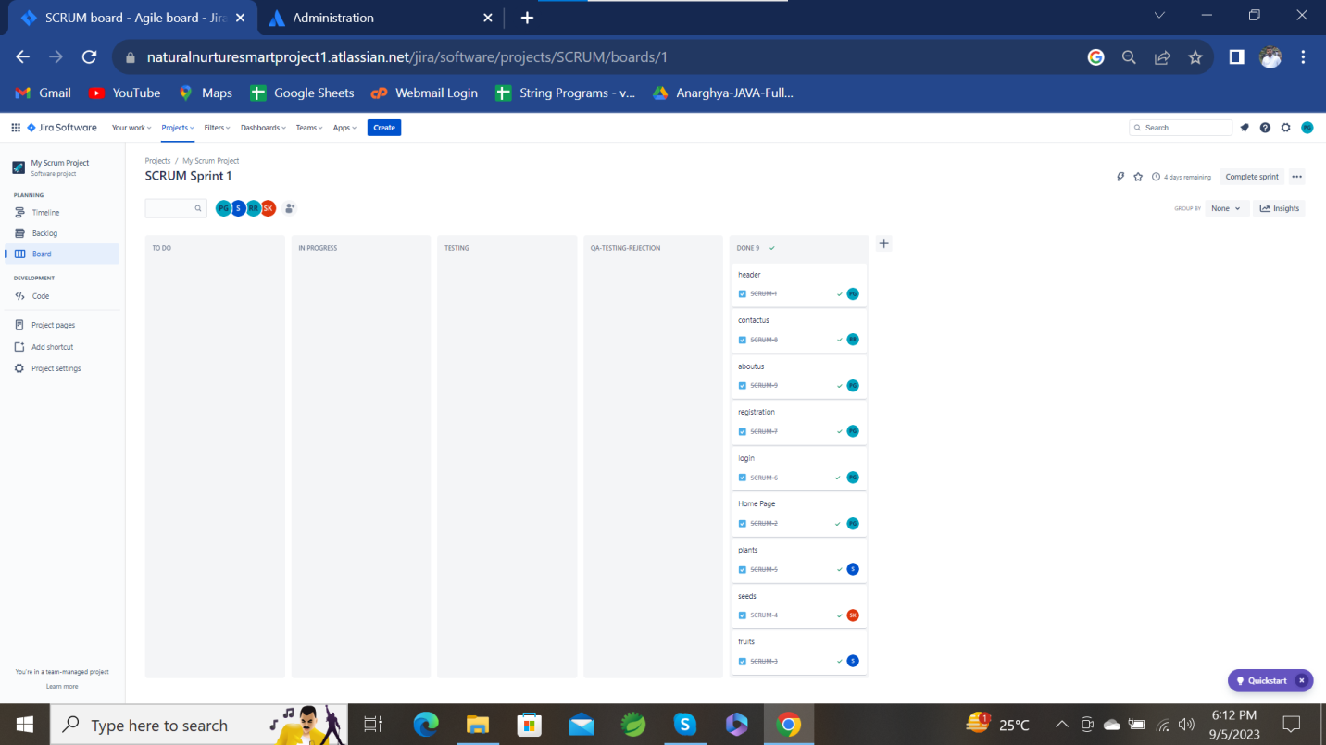

**Thank You**